Lecture No.33 PARASITOLOGY DR. Raad H.H.

Order: Hemiptera (Cimicidae)
- Over 55,000 described species, but only about 100 parasitic species which are ectoparasites on birds and/or mammals
- labrum short, not easily seen
- labium elongate, forms tube containing mandibles and maxillae
- maxillae enclose a canal, which forms a channel in which fluids (food) are drawn up and also a salivary canal where saliva can be injected
- endosymbiotic bacteria which are important for bug maturation and growth
- 2 families with parasitic members (Cimicidae and Reduviidae)
Family: Cimicidae
- wingless
- small-medium in size
- endosymbiotic bacteria in mycetomes, which are 2 organelles in the abdomin near the gonads
- generally reddish-brown in color
- dorso-ventrally flattened
- 4 jointed antennae, conspicuous
- compound eyes without ocelli
- feed quickly, usually in 5-10 minutes
- usually nocturnal
- 22 genera, 12 of which are known from bats; most species feed on birds or bats
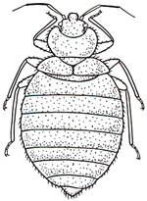

- life-cycle
  - adults live in cracks and crevices, nocturnal feeders usually
  - suck blood frequently; engorge for 5-10 minutes at a time
  - blood meal needed for male to mate; male stabs female near the 5th abdominal segment with a male sexual organ termed a paramere (termed traumatic insemination)
  - sperm enter as a packet; migrates to oviducts
  - 200-500 eggs layed in batches of 10-50 eggs each; blood meal needed for female to oviposit
  - eggs hatch, generally in about 10 days
  - 5 nymphal instars over a period of 5-6 weeks to a half a year; each instar must have a blood meal
  - final molt into adults
  - may live up to 1.5 years without a blood meal
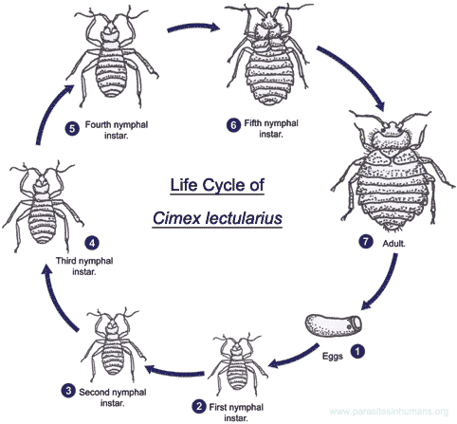

- typical species
  - Cimex hemipterus (bedbug; tropical; feeds on many species of mammals, especially bats)
  - Cimex lectularius (Indian bedbug; cosmopolitan; mainly in temperate regions of the world; feeds on a variety of mammals and even birds)
  - Leptocimax boueti (bedbug; West Africa; feeds on a variety of animals, especially bats)
  - Oeciacus vicarius (cliff swallow nests)
- when sympatric, Cimex lectularis and Cimex hemipterus will undergo frequent interspecific mating. The resulting eggs normally do not hatch, however
- pathology includes itching at the site of the bite, loss of sleep, some anemia during heavy infestations, and (rarely) hepatitis B transmission to humans
- there are a lot of ancient "remedies" that employed bedbugs. I list only a few of the more interesting ones that were sometimes employed
  - in China, boils were cured by pounding 7 bedbugs throughly with white rice and applying the paste to the lesion
  - in Europe, cataracts were treated by applying to the eye a mixture of crushed bedbugs, salt, and mules milk. For warts, bedbugs were mixed with the blood of a tortoise and then applied to the wart. For earache, a mixture of bedbugs and honey could be applied. And, my favorite, for vegetius (inability to pass urine), one could place a live bedbug into the penis or vagina. The movement of the bug was supposed to cause the urethra to open.
Family: Reduviidae
- about 2,500 known species
- most species predators, and are often termed assassin bugs, kissing bugs, cone-nose bugs, reduviids, vinchuca, etc.
- many species feed on common pests
- endosymbiotic bacteria in epithelial cells along gut
- most do not feed on vertebrates, although they may bite if disturbed and the bite can be quite painful
- when not in use, the proboscis resides in a groove on the ventral surface
- most species large
- winged in most cases
- narrow head
- large eyes, laterally
- 2 ocelli behind eyes
- antennae slender, with 4 segments each
- some species in subfamily Triatominae are vectors of Trypanosoma cruzi (Chaga's disease)
- most nocturnal
- blood feeders; tend to feed on a wide range of hosts if available
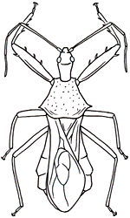

- life-cycle
  - adults free-living
  - eggs deposited on ground, in trees, etc; anywhere from a few dozen to thousands may be layed, depending upon the species
  - 5-more nymphal instars
  - last molt into adults
  - mating involves courtship behavior
- a species occurring in and around Manhattan, KS is Triatoma sanguisuga. This reduviid predominately feeds on woodrats (Neotoma floridana) and sometimes hispid cotton rats (Sigmodon hispidus). It resides in their nests. However, many other mammalian hosts may be bitten, imcluding humans.

Subclass Pterygota
Endopterygota

Order: Coleoptera (beetles)
- Beetles are best characterized by the first set of wings, which have been hardened into structures termed "elytra."
- Elytra protect the more delicate hindwings.
- Mesothorax and metathorax more closely connected to abdomen so that the prothorax is really the structure that serves as a typical thorax
- Antennae of adult with 11 articles
- Genitalia retract into the abdomen
- Most parasitic species feed on hair fragments, dead skin, secretions, dried feces, etc.
- Larvae of many species found only associated with nests whereas adults on host animal
- 4 suborders, most free-living. Few parasitic.
- One family, the Leptinidae (mammal nest beetles) are ectoparasites on mammals. Four genera (Leptinillus, Leptinus, Platypsyllus, and Silphopsyllus) are known to exist. The following represent the North American species:
  - Platypsyllus castoris occurs on the fur of beaver in North America and Europe. The beetle is dorso-ventrally flattened, possesses no eyes or wings, and has ctenidia over its body. Sometimes termed the "beaver flea." Both adult and larva feed on epidermal exudates. Some authors place this beetle within a separate family Platypsyllidae.
  - Leptinillus aplodontiae is found on Mountain beaver of North America.
  - Leptinillus validus is found in the fur of beaver in North America. Larvae are scavengers within the beaver nest whereas the adults feed on host skin and exudates.
  - Leptinus occidentamericanus occurs on a variety of small mammals (and nests) in North America, especially in the Spring and Fall.
  - Leptinus orientamericanus occurs in North America. All members of the genus east of the Mississippi river are probably this species. This parasite has been reported most commonly in the Fall and Winter from short-tailed shrews (Blarina brevicauda) and moles (Scalopus aquaticus). Also found on other rodents (i.e. Peromyscus, Microtus) and insectivores, and in nests.
  - Leptinus americanus occurs within the central United States , Found associated with mice and moles, and in nests.
  - NOTE: Leptinus testaceus is often reported erroneously from North America. However, this is a European species.

Order: Lepidoptera (moths and butterflies)
- Although a few moths are wingless, most lepidopterans have two pair of wings covered by tiny, overlapping scales. Butterflies generally fold their wings vertically at rest whereas moths generally lay their wings flat at rest
- antennae club-shaped in butterflies, whereas they are long and slender in female moths and feathery in male moths
- mouthparts usually form a sucking tube termed a "haustellum," which is coiled. The microlepidopterans have mouthparts that have atrophied whereas the Micropterygidae have chewing mouthparts
- an ocellus is present above each eye
- abdomen with 10 segments
- body and legs covered with fine hair
- larvae with 3 pair thoracic legs
- larvae with mandibulate mouthparts
- very few parasitic, although some moths have adapted the life-style. Parasitic forms can be divided into three general groups:
  - those scant species with blood or secretion sucking larvae
    - Plodia interterpunctella (Indian meal moth) has rarely been reported to accidently infest animals
    - Some members of the Epipyropidae (parasitic moths) have larvae that feed upon other insects (i.e. cicadas, planthoppers, etc.). Although most species are Asian, a few species occur elsewhere including the Western Hemisphere
  - lachryphagous (eye-frequenting) moths feed on eye discharges and some genera feed on other mammalian secretions. Some are facultative in this regard, whereas a few rely totally on this strategy. Ungulates and elephants, rarely humans, are commonly targeted.
  - skin-piercing blood-sucking moths (Noctuidae) feed exclusively on the blood of mammals
    - Calyptra (syn. Calpe) eustrigata (Asian vampire moth) was first reported to feed on blood. This moth uses its mouthparts to pierce the skin and suck blood from a variety of mammals including humans. It occurs throughout southeast Asia (Thailand, Laos, Indonesia, Malaysia).
    - Calyptra labilis (Thailand), Calyptra minuticornis (Thailand and northwest Malaysia), and Calyptra orthograpta (northern Thailand and northern Laos) have also been reported to feed on mammals (i.e. water buffalo, sambar, elephant, zebu, tapir) and, experimentally, humans.

